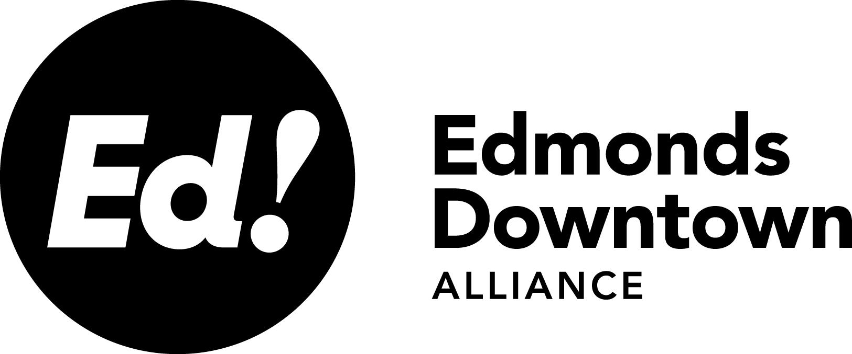 | January 9, 2020  8:00am – 9:30am  Edmonds Center for the Arts  410 4th Ave N

Type of meeting: | Board Meeting | Taking Minutes: |  | Carol Sheldon
Please read: | 12/12/19 minutes | Prepare to share: |  | Committee updates
Ed! Mission: Created by the Edmonds City Council in early 2013, we are a focused, funded organization that
supports and improves business conditions in Edmonds. Our goal is to ensure our downtown stays lively, attractive and prosperous.
Agenda
Call to Order |  | Matt McCulloch |  | 1
Public Comment |  |  |  | 5
Approval of 12/12 Minutes |  | Matt McCulloch |  | 5
President’s Report |  | Matt McCulloch |  | 5
- Committee Meetings
- “Year in Review” for MEN
New Businesses in the BID |  | Matt McCulloch |  | 5
City Update |  | Patrick/Cindi |  | 10
Committee Updates  - Marketing  - Holiday Results  - Approve Digital Ad Budget ($5,500)  - Approve Half of the Website Maintenance Budget ($1,000)  - Appearance & Environment/Parking  - Approve Umbrella Budget ($9,450)  - Communication & Outreach  - Approve MEN Contract ($330)  - Approve Half New Member Communication Budget ($200)  - Grant Program  Administration  - Approve Supply Budget ($300)  - Approve Operating Expenses Budget ($625) |  |  |  | 30
New Business |  | All |  | 5
Adjourn

